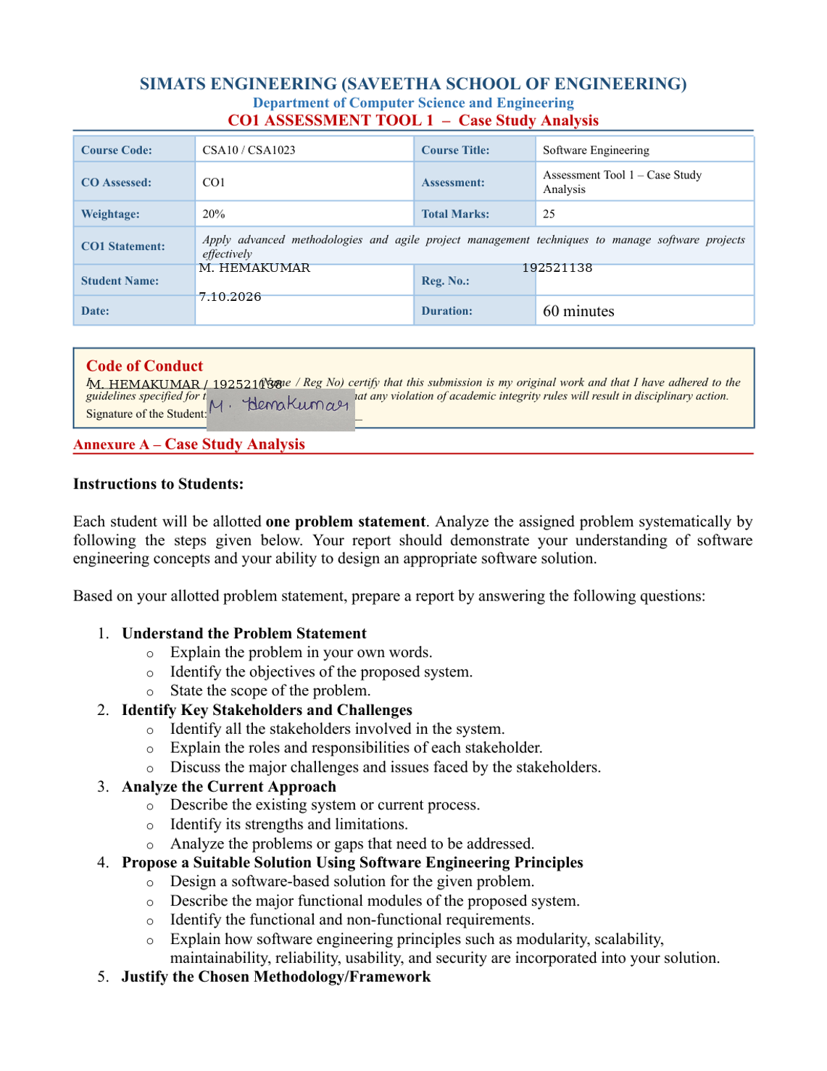
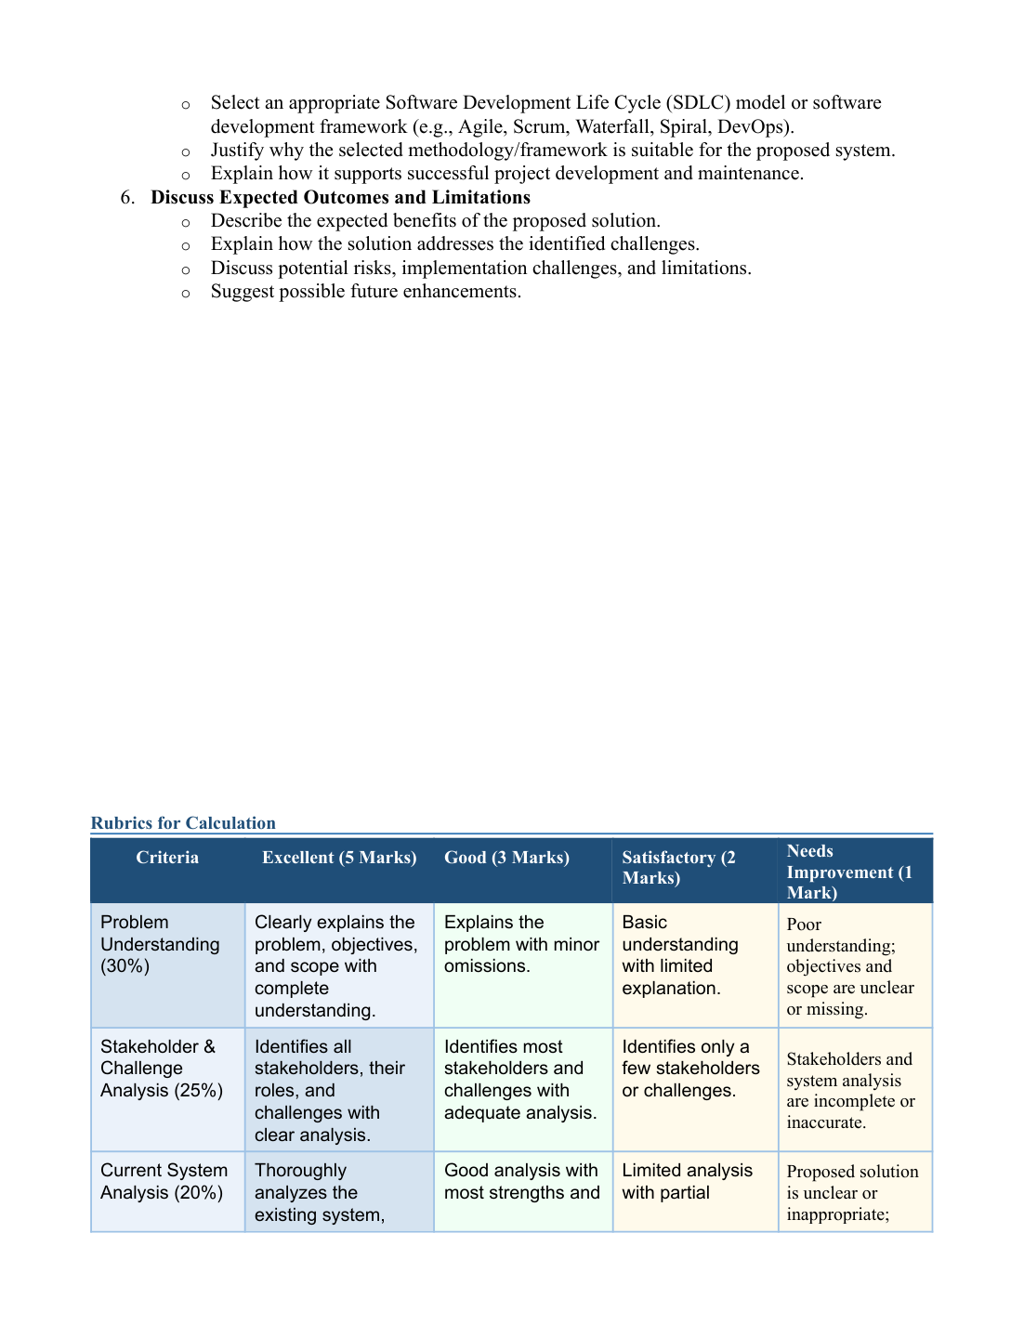

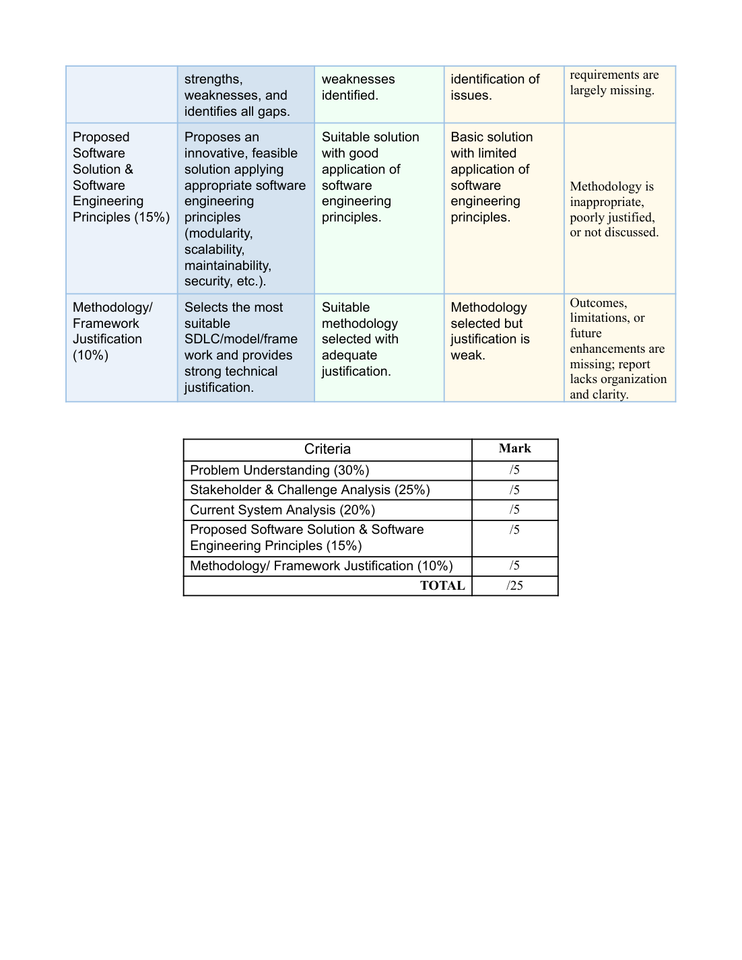

CASE STUDY ANALYSIS
Green CI/CD Optimization and Intelligent Build Scheduling Platform
1. Understand the Problem Statement
Large software organizations execute thousands of builds, tests, scans, and deployments as part of their CI/CD processes. Repeated builds, unnecessary test execution, inefficient runner utilization, and poorly scheduled workloads can increase computing cost and energy consumption. The proposed Green CI/CD Optimization and Intelligent Build Scheduling Platform analyses software pipeline execution and resource usage, then recommends or applies resource-efficient build, test, and deployment strategies while preserving the required quality and security gates.
Objectives
Analyse CI/CD execution and resource consumption.
Identify redundant builds and unnecessary test execution.
Optimize test selection while preserving the required level of software quality.
Schedule CI/CD workloads efficiently across available computing resources.
Monitor energy and infrastructure indicators whenever the required measurements are available.
Maintain mandatory security and quality gates throughout the optimization process.
Provide sustainability and pipeline-efficiency reports for engineering and management teams.
Scope
The platform focuses on optimizing CI/CD pipelines in large software organizations. It covers build, test, scan, deployment, workload scheduling, resource monitoring, quality and security gates, and engineering and sustainability dashboards. The system is designed to integrate with containerized CI/CD environments.
2. Identify Key Stakeholders and Challenges
Key Stakeholders
Software Developers develop application code and depend on fast and reliable CI/CD feedback.
DevOps Engineers manage pipelines, runners, containers, infrastructure, and deployments.
QA/Test Engineers maintain test suites and ensure that the software meets required quality standards.
The Security Team manages security scans and ensures that required security gates are satisfied.
Engineering Managers monitor delivery efficiency, infrastructure cost, and engineering performance.
The Sustainability Team monitors sustainability indicators and works toward reducing resource and energy consumption.
Major Challenges
Large numbers of CI/CD jobs and repeated builds can create unnecessary computational work.
Unnecessary test execution consumes computing resources even when tests are not affected by code changes.
Inefficient or poorly scheduled runners can leave available resources underused.
High infrastructure usage can increase operational cost.
Energy consumption can be difficult to measure when suitable indicators are unavailable.
Pipeline optimization must be performed without increasing release risk.
Security and quality gates must remain active even after optimization.
The platform must integrate with different containerized CI/CD environments.
3. Analyze the Current Approach
In the current approach, CI/CD pipelines generally execute predefined build, test, scan, and deployment steps whenever pipeline conditions are triggered. This provides a repeatable automated delivery process, but it can also result in repeated work, unnecessary tests, inefficient resource allocation, and limited visibility into sustainability metrics.
Strengths
The existing approach provides automated build and test execution.
It supports continuous integration and continuous delivery.
It provides a repeatable software delivery process.
Automated quality and security checks can be included in the pipeline.
Limitations and Gaps
The current approach may execute redundant builds and tests even when they are not affected by code changes. Workloads may not be scheduled according to current resource availability, while energy and infrastructure indicators may not be monitored. Sustainability and pipeline-efficiency reports may therefore be limited or unavailable. In addition, optimization decisions may not be sufficiently intelligent or data-driven.
4. Propose a Suitable Solution Using Software Engineering Principles
The proposed platform collects CI/CD execution data and resource information, analyses pipeline behaviour, detects redundant work, selects relevant tests, schedules workloads efficiently, and monitors resource and energy indicators where available. Before optimized execution is allowed to proceed, the system preserves the required security and quality gates. This provides a controlled approach to improving efficiency without weakening software quality or security.
Major Functional Modules
Pipeline Analysis Module – analyses build, test, scan, and deployment execution.
Redundant Build Detection Module – identifies repeated or unnecessary build work.
Intelligent Test Selection Module – selects relevant tests while preserving required quality.
Intelligent Workload Scheduling Module – schedules jobs efficiently across available runners.
Resource and Energy Monitoring Module – tracks CPU, memory, infrastructure, and available energy indicators.
Security and Quality Gate Module – ensures mandatory security and quality checks are maintained.
Dashboard and Reporting Module – displays pipeline-efficiency and sustainability indicators.
Functional Requirements
Collect CI/CD pipeline execution and resource data.
Detect redundant builds and unnecessary test execution.
Recommend or apply optimized test selection.
Schedule CI/CD workloads efficiently.
Monitor resource and available energy indicators.
Maintain security and quality gates.
Generate sustainability and pipeline-efficiency reports.
Provide dashboards for engineering and sustainability metrics.
Integrate with containerized CI/CD environments.
Non-Functional Requirements
- Performance – the analysis should provide results without creating major pipeline delays.
- Scalability – the platform should support large numbers of pipelines, jobs, and projects.
- Reliability – optimization must not reduce delivery reliability.
- Security – pipeline, project, and infrastructure information must be protected.
- Usability – dashboards and recommendations should be easy to understand.
- Maintainability – individual modules should be easy to update and maintain.
Software Engineering Principles
- Modularity – separate modules handle analysis, test selection, scheduling, monitoring, and reporting.
- Scalability – the platform can be expanded to support more pipelines and workloads.
- Maintainability – modules can be modified independently.
- Reliability – required quality and security gates remain active.
- Usability – dashboards provide clear engineering and sustainability information.
- Security – access and pipeline information are protected.
Proposed System Flowchart
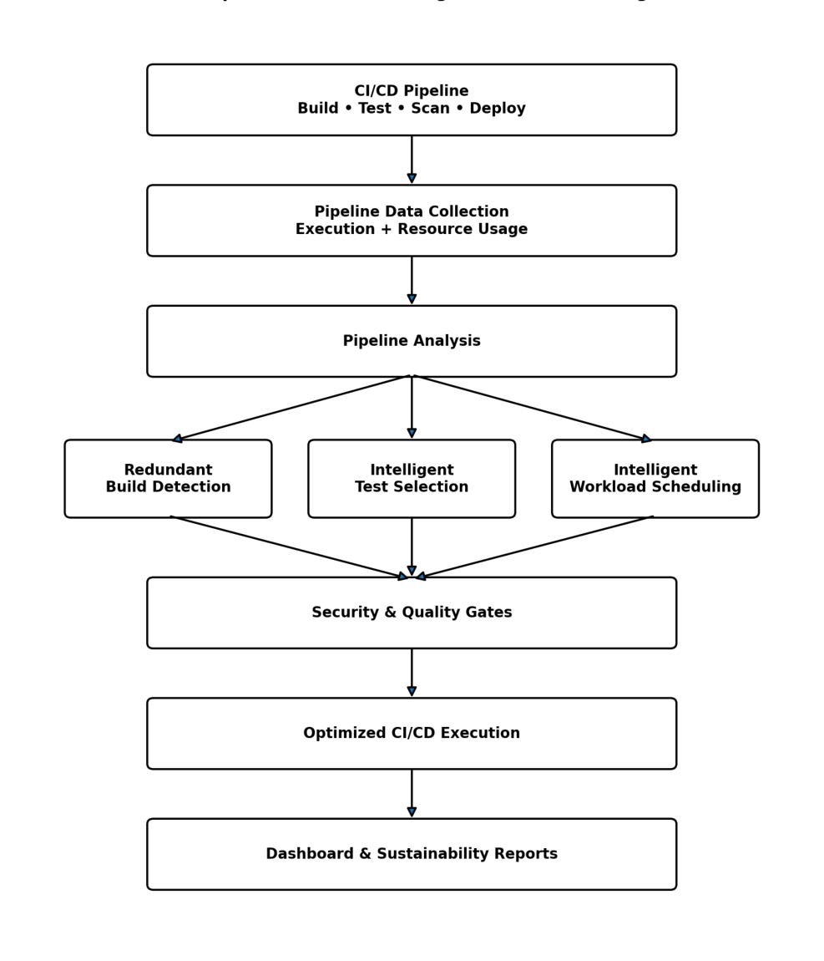
Figure 1: Flowchart of the proposed Green CI/CD optimization platform.
5. Justify the Chosen Methodology/Framework
Agile with Scrum is suitable for this platform because CI/CD optimization requirements can change based on feedback from developers, DevOps engineers, QA teams, security teams, and sustainability teams. Scrum supports incremental development, continuous feedback, and regular refinement of optimization features.
Reasons for Choosing Agile/Scrum
- The platform can be developed incrementally in short sprints.
- User feedback can be collected after each sprint.
- Pipeline optimization features can be improved continuously.
- New CI/CD and container integrations can be added gradually.
- Security and quality requirements can be tested continuously.
- Problems can be identified and corrected early.
Example Sprint Plan
Sprint 1 – CI/CD pipeline data collection.
Sprint 2 – Redundant build detection.
Sprint 3 – Intelligent test selection.
Sprint 4 – Intelligent workload scheduling.
Sprint 5 – Resource and energy monitoring.
Sprint 6 – Dashboard and sustainability reporting.
6. Discuss Expected Outcomes and Limitations
Expected Outcomes
- Reduce unnecessary CI/CD computation.
- Improve build and test efficiency.
- Reduce infrastructure cost and resource usage.
- Maintain software quality and delivery reliability.
- Provide measurable sustainability indicators.
- Support sustainable DevOps practices.
Risks and Implementation Challenges
Incorrect test optimization could miss required tests if the selection mechanism is not properly designed.Automatic optimization must not bypass critical quality or security gates.Different CI/CD platforms may require different integrations.Energy indicators may not be available in every environment.Large and complex pipelines may require extensive analysis and configuration.
Limitations
Energy consumption may not always be measured directly.
Optimization quality depends on the available pipeline and resource data.
Integration effort can vary between CI/CD platforms.
Automatic scheduling decisions require continuous monitoring.
Future Enhancements
Use machine learning to predict build and test requirements.
Add more CI/CD platform and container integrations.
Improve energy-consumption prediction.
Add AI-based optimization recommendations.
Introduce automatic resource scaling.
Provide advanced predictive workload scheduling.
Conclusion
The Green CI/CD Optimization and Intelligent Build Scheduling Platform provides a software-based approach to reduce unnecessary computation, improve pipeline efficiency, lower infrastructure resource usage, and support sustainable DevOps. The proposed modular solution maintains the required security and quality gates while providing useful engineering and sustainability metrics.

